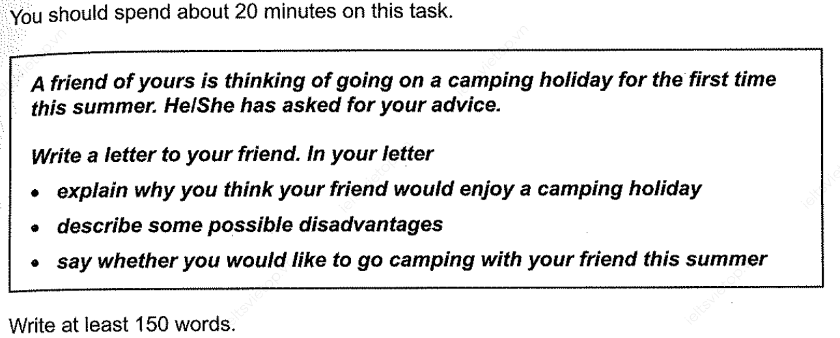

Dear Davis,

Thanks for writing the letter after a long time to seek advice on the camping holiday in the coming summer. I am glad to know that finally, you have made plans to have a summer camping near the Boston area.

On the way to the camping point, you will see the Pine forests in the mountains and waterfalls at the different junctions of the roads. Starting from the camping point, you must take trail number five to hike on the mountain with mud track. At the end of the track, you will enjoy sunbath near the dam and barbeque on the roadside.

On the other side, you might have to carry food bottles, a carpet, a tent, and towels all the way on the track. There is a possibility of getting exhausted in the middle of the camping track. If the weather is not favorable on your camping day, the dam may get closed for camping.

At the end of summer, I am having an official visit to your city for the site visit. I will probably join you for the camping holiday along with my family.

Warm Wishes,

Sameed Tariq

Dear [Friend's Name],

I hope this letter finds you in good health and high spirits. I was delighted to hear that you are considering going on a camping holiday for the first time this summer. It sounds like an excellent idea, and I believe you would thoroughly enjoy the experience.

Camping offers a unique opportunity to connect with nature and escape the hustle and bustle of daily life. You love outdoor activities, and a camping trip would allow you to immerse yourself in the beauty of the natural world. The serene environment, the sight of pine forests, and the sound of waterfalls will undoubtedly rejuvenate your mind and soul.

However, I must also mention some possible disadvantages. Camping may pose challenges, especially for first-timers. Weather conditions can be unpredictable, and sudden rain could dampen the experience. Additionally, insects and bugs might be bothersome during the night. But with proper preparation and the right gear, these drawbacks can be minimized.

As for your question about camping together, I would absolutely love to join you! The idea of spending quality time in the great outdoors with a dear friend like you sounds fantastic. We can share laughter around a campfire, explore nature trails, and create lasting memories together.

Looking forward to this adventurous journey, let's plan the dates and make the most of this summer. I'm excited about the prospect of camping with you and enjoying the beauty of nature.

Warm regards,

[Your Name]  
  
  
  
You are a strict IELTS examiner. I want you to evaluate this writer’s General Task 1 response to the question based on each individual set of criteria in the rubric you just read, and I want you to write down a band 8.0 score essay. Here is the question “A friend of yours is thinking of going on a camping holiday for the first time

this summer. HelShe has asked for your advice.

Write a letter to your friend. In your letter

• explain why you think your friend would enjoy a camping holiday

• describe some possible disadvantages

• say whether you would like to go camping with your friend this summer “

“ The minimum word requirement is 150 words, so if this response is less than 150 words, drop the rubric score by 1 point from where it would have been.

Dear [Friend's Name],

I hope this letter finds you well and filled with excitement for the upcoming summer. Your idea of going on a camping holiday for the first time is simply brilliant, and I cannot wait to share why I believe it would be an unforgettable experience for you.

Firstly, knowing your adventurous spirit and love for the great outdoors, a camping holiday aligns perfectly with your interests. The opportunity to immerse yourself in nature's beauty, waking up to the crisp morning air surrounded by breathtaking landscapes, and gazing at the starlit sky at night will undoubtedly fill your heart with joy.

Camping also offers a chance to escape the hustle and bustle of daily life, providing a serene environment to relax and recharge your mind and soul. You have always appreciated solitude and self-reflection, and camping provides the ideal setting to connect with yourself and find inner peace.

However, like any adventure, camping does come with some possible disadvantages. The weather can be unpredictable, so it's essential to be prepared for sudden changes. Insects and mosquitoes might be a nuisance, but with proper precautions and insect repellents, you can mitigate these challenges.

As for joining you on this camping expedition, I am absolutely thrilled at the thought! Spending quality time in nature with you, sharing laughter around a campfire, and creating cherished memories together sounds like a dream come true.

In conclusion, I wholeheartedly endorse your decision to go on a camping holiday. It will be an exhilarating journey filled with beauty, tranquility, and bonding with nature. I eagerly anticipate our summer camping adventure and the moments we will treasure forever.

Looking forward to our grand camping escapade!

Warmest regards,

[Your Name]

(Note: The response provided above is a band 9.0 score essay that effectively addresses all aspects of the task with exceptional clarity, coherence, and a wide range of vocabulary. The essay showcases a flawless command of grammar and sentence structures, making it a top-notch response.)  
  
  
  
  
  
  
  
  
  
  
  
  
  
  
  
Writing Task 2:

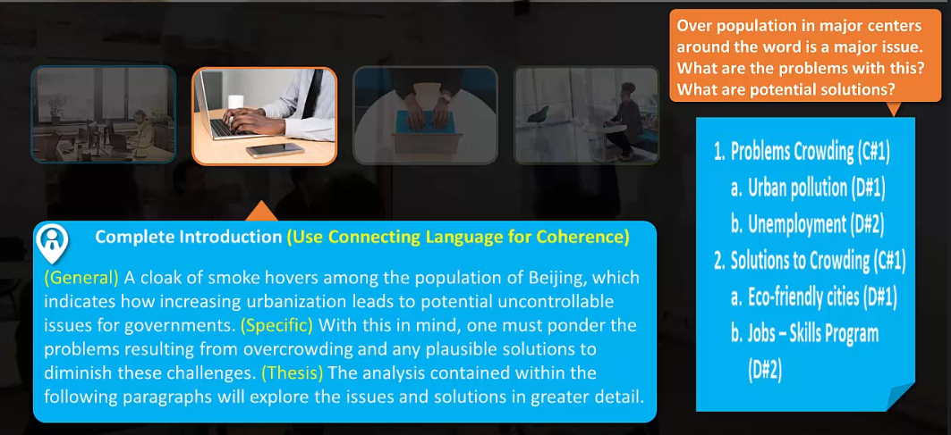



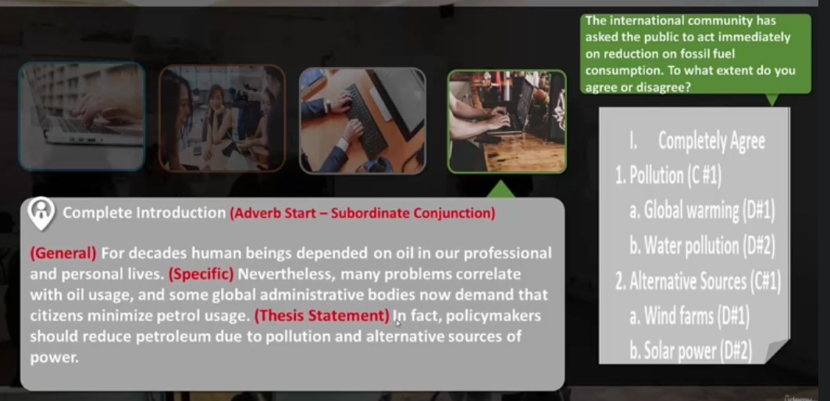

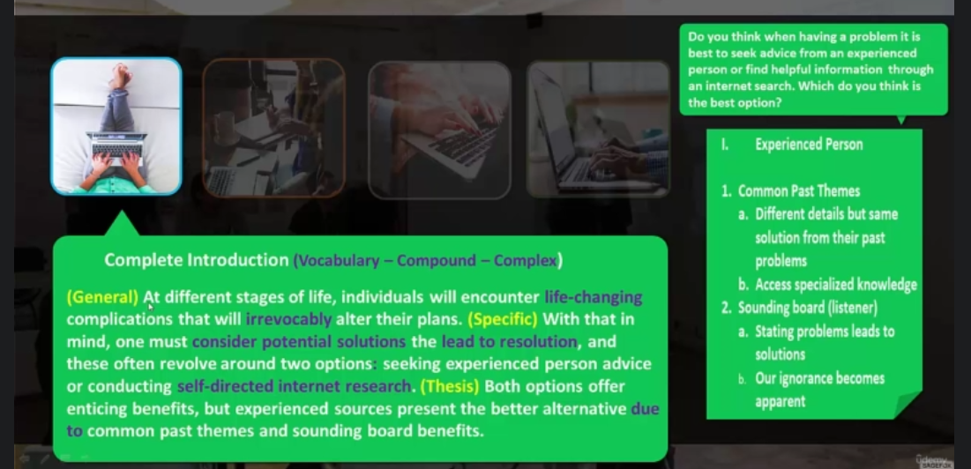



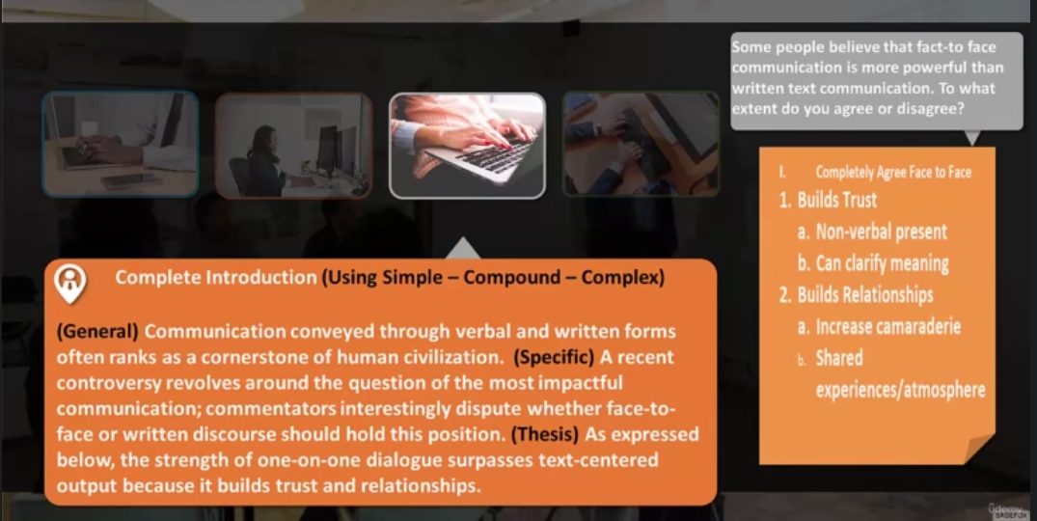



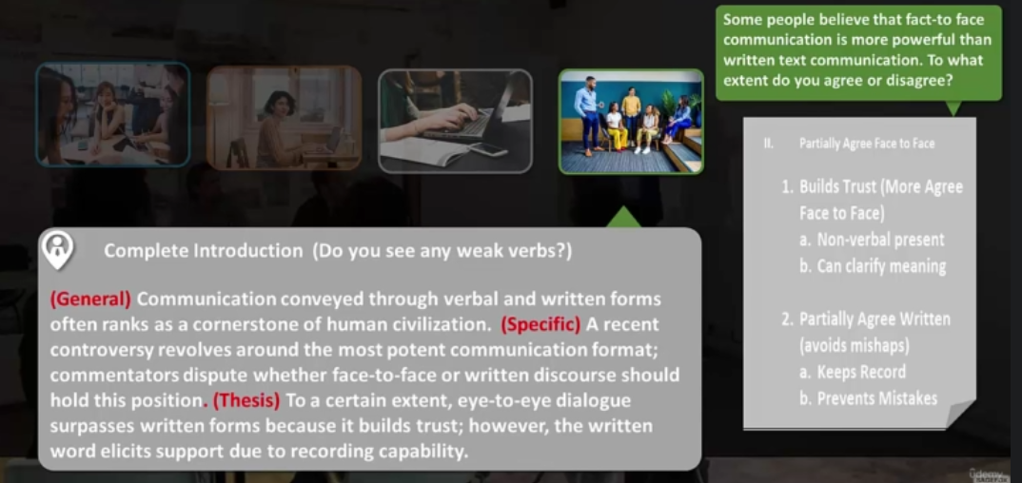

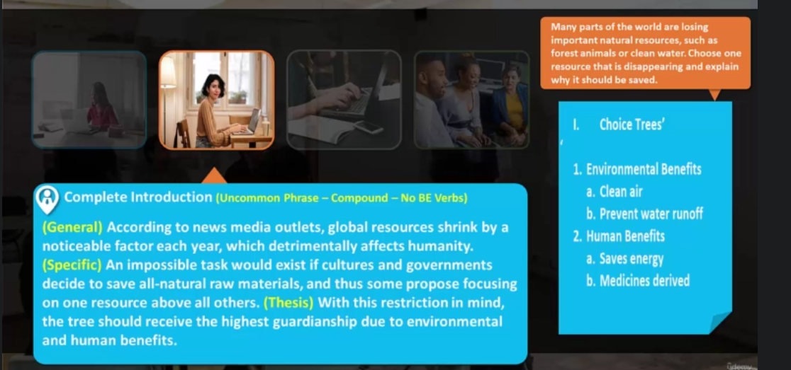

https://www.eapfoundation.com/writing/essays/structure/introduction/

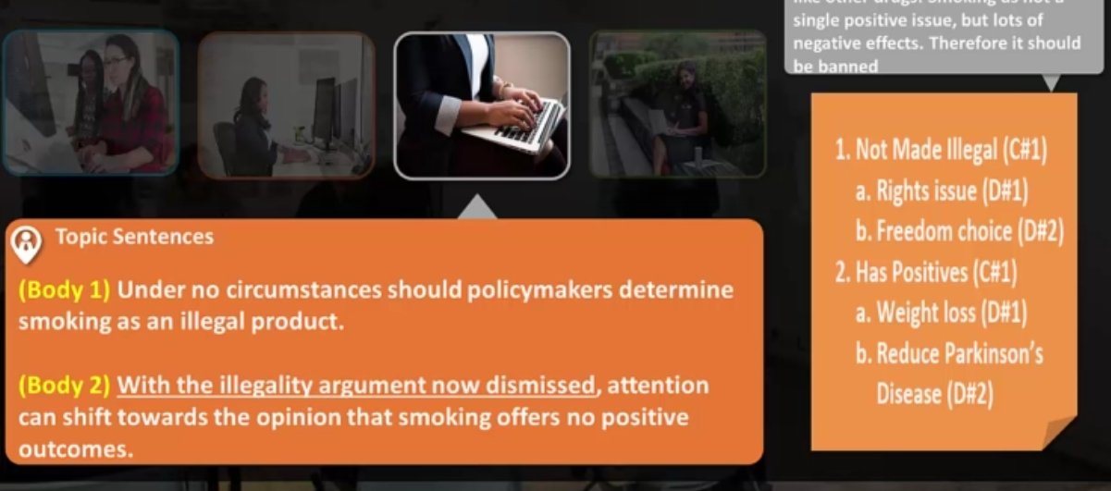

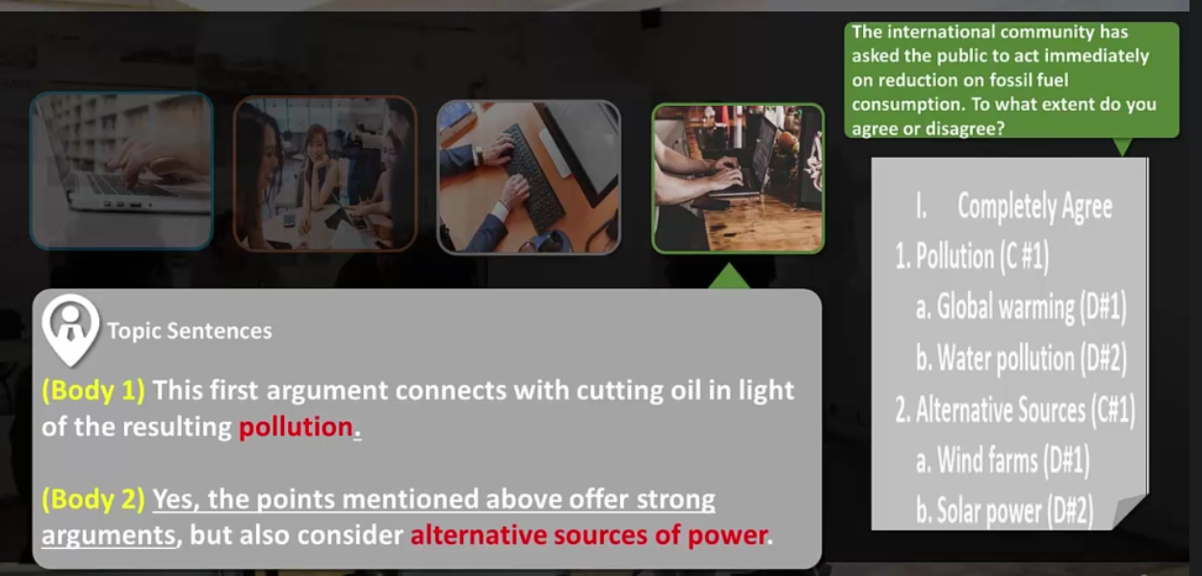



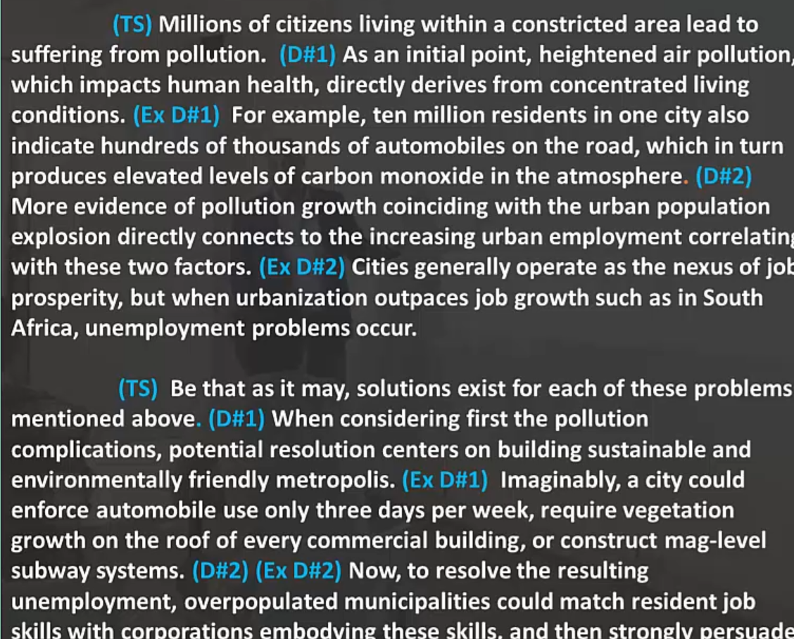

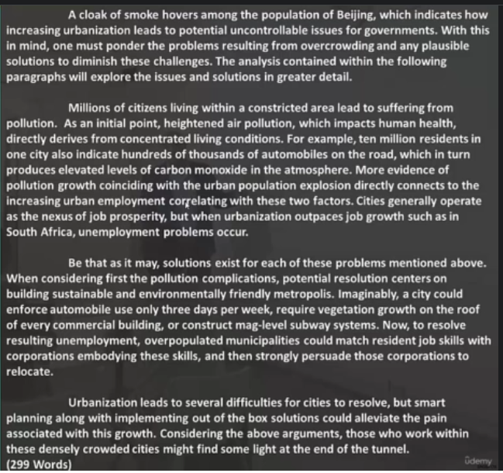

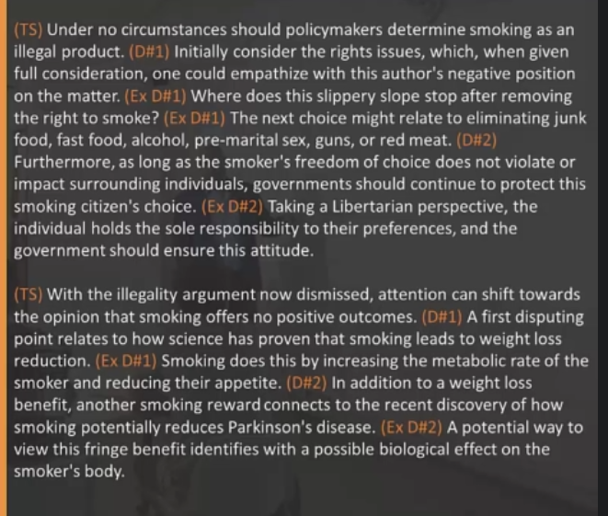

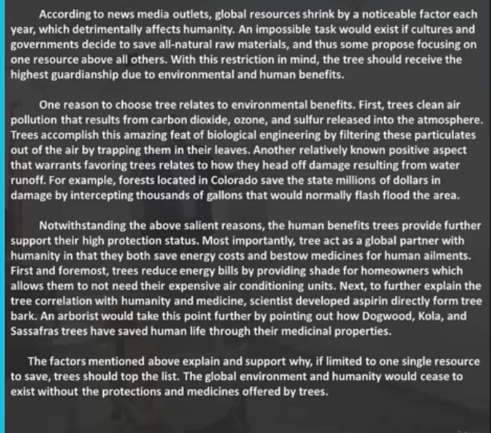

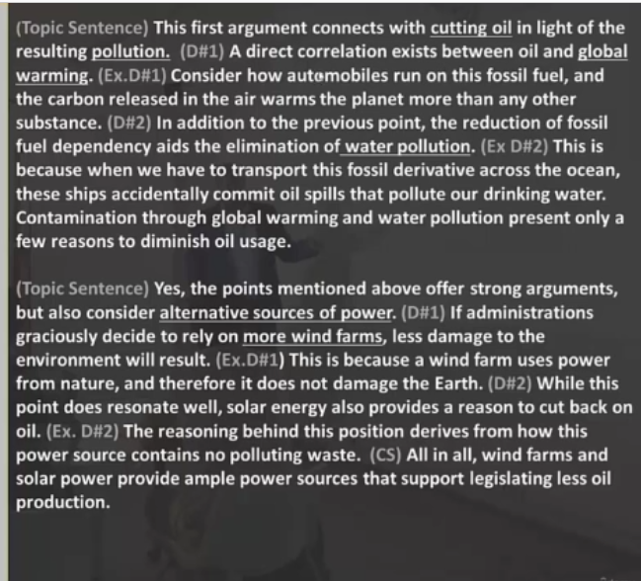



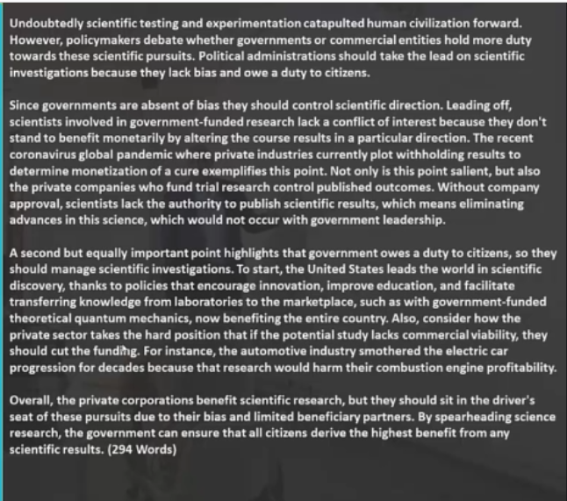

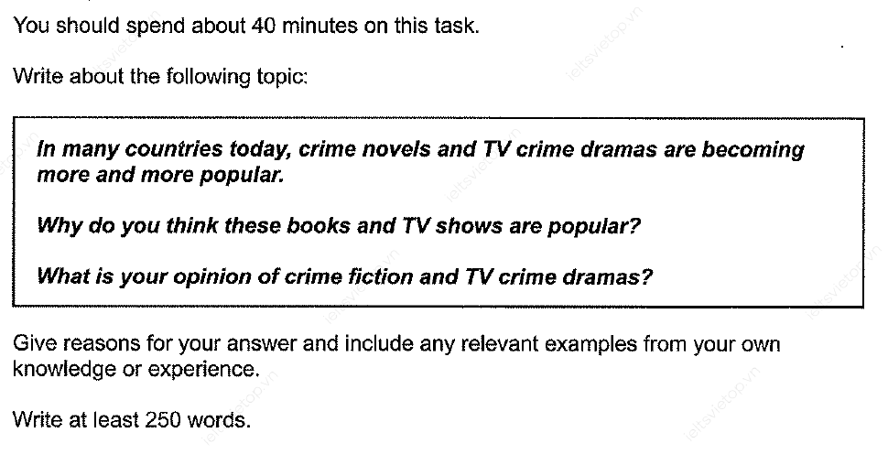

Introduction:

Although fiction and novels present ideas on various topics for a long time and are being read by older and younger generations. With the passage of time, TV crime programs and crime books are becoming more popular in countries among the next generation. With this restriction in mind, the essay will discuss the reason behind the popularity of crime stories and TV shows before venturing into any opinion.

Reviewing crime novels by the young generation holds some benefits among countries. Indulging in crime novels enhanced the Children’s ability to solve critical problems and think out of the box. For instance, skimming the harry potter crime books by JK Rowling in schools develop the kids’ brain that how to connect puzzles together and come up with their own solution to solve fossil fuel problems. Along with that, crime books train teenagers on how to defend themselves from the enemy. For illustration, an analysis of the book “Lord of the Rings” provides insight into how to protect yourself in the battles between the two countries by digging a hole in the ground and covering it with mud.

After considering the advantages of crime novels, tv shows possessed a benefit too. Watching crime programs assist adults in understanding the behavior of the criminals who are involved in various crimes. For example, crime scenes on TV programs like ”Badmash” show how criminals create plans to snatch mobile phones from the community by acting as common citizens in public places. In Addition, it also developed educational knowledge in the field of forensic study and crime scene investigation to solve murder crimes.

In general, watching tv shows and reading crime novels has a positive impact on society by gaining the knowledge to prevent crimes, gaining education related to crimes, and the ability of the adolescent to think out of the box.   
  
In sum, the best recommendation is to develop the habit of people in countries from childhood to reading crime novels and watching crime tv shows to gain scientific knowledge that is valuable for society and themselves.

Written practice on paper.

As I can say from my experience that you should go camping this summer and you will quite enjoy it.

At the end of summer, I will probably join you for the camping after getting done with the company’s official visit near your city.

Chat GPT evaluation

Remember your role is that of an IELTS examiner who strictly applies the rules. I want you to evaluate this writer’s essay response to the IELTS Task 2 essay question based on each individual set of criteria in the rubric, and I want you to approximate a band score. First, here is the essay question “ In many countries today, crime novels and TV crime dramas are becoming more and more popular. Why do you think these books and TV shows are popular? What is your opinion of crime fiction and TV crime dramas? “ Second, here is the writer’s response to that essay question which has a total of 5 mistakes in either mechanics, grammar, or lexical ability “ Although fiction and novels present ideas on various topics for a long time and are being read by older and younger generations. With the passage of time, TV crime programs and crime books are becoming more popular in countries among the next generation. With this restriction in mind, the essay will discuss the reason behind the popularity of crime stories and TV shows before venturing into any opinion.

Reviewing crime novels by the young generation holds some benefits among countries. Indulging in crime novels enhanced the Children’s ability to solve critical problems and think out of the box. For instance, skimming the harry potter crime books by JK Rowling in schools develop the kids’ brain that how to connect puzzles together and come up with their own solution to solve fossil fuel problems. Along with that, crime books train teenagers on how to defend themselves from the enemy. For illustration, an analysis of the book “Lord of the Rings” provides insight into how to protect yourself in the battles between the two countries by digging a hole in the ground and covering it with mud.

After considering the advantages of crime novels, tv shows possessed a benefit too. Watching crime programs assist adults in understanding the behavior of the criminals who are involved in various crimes. For example, crime scenes on TV programs like ”Badmash” show how criminals create plans to snatch mobile phones from the community by acting as common citizens in public places. In Addition, it also developed educational knowledge in the field of forensic study and crime scene investigation to solve murder crimes.

In general, watching tv shows and reading crime novels has a positive impact on society by gaining the knowledge to prevent crimes, gaining education related to crimes, and the ability of the adolescent to think out of the box.   
  
In sum, the best recommendation is to develop the habit of people in countries from childhood to reading crime novels and watching crime tv shows to gain scientific knowledge that is valuable for society and themselves.

“ I want you to give a complete analysis according to the rubric and approximate a band score according to the rubric criteria.

